# OPERATING SYSTEMS CONTROL POINT

1.- We have Oxygen and Hydrogen atoms that go into a tank for a chemical reaction to create water. Two atoms of Hydrogen have to react with an atom of Oxygen to make a molecule of water H20. We connect the hydrogen source and the oxygen source with the tank and atoms of hydrogen pass into the tank two by two and atoms of oxygen one by one. They have to wait to each other to make the reaction and then go out of the tank allowing other atoms come into the tank. Here you can see an output of the program with 20 atoms of hydrogen and 10 of oxygen.

----------------

hydrogen 1 reacts to create water

oxygen 0 reacts to create water

hydrogen 0 reacts to create water

----------------

hydrogen 3 reacts to create water

oxygen 1 reacts to create water

hydrogen 2 reacts to create water

----------------

hydrogen 5 reacts to create water

oxygen 2 reacts to create water

hydrogen 4 reacts to create water

----------------

hydrogen 7 reacts to create water

hydrogen 6 reacts to create water

oxygen 3 reacts to create water

----------------

oxygen 4 reacts to create water

hydrogen 9 reacts to create water

hydrogen 8 reacts to create water

----------------

hydrogen 12 reacts to create water

hydrogen 10 reacts to create water

oxygen 5 reacts to create water

----------------

oxygen 6 reacts to create water

hydrogen 16 reacts to create water

hydrogen 11 reacts to create water

----------------

hydrogen 13 reacts to create water

oxygen 7 reacts to create water

hydrogen 15 reacts to create water

----------------

oxygen 8 reacts to create water

hydrogen 14 reacts to create water

hydrogen 17 reacts to create water

----------------

hydrogen 18 reacts to create water

hydrogen 19 reacts to create water

oxygen 9 reacts to create water

Goodbye

2.- In a supermarket, customers for doing the checkout, go to a checkout queue. There is only one checkout queue but there are 3 cashier boxes. A customer waits if all the cashiers are busy. If there are free cashiers a customer goes to one free cashier, waits till everything is checked and pay. The cashier waits for a customer and then does the check and wait for the customer payment.

Here is the output of a program with 10 customers an 3 cashiers.

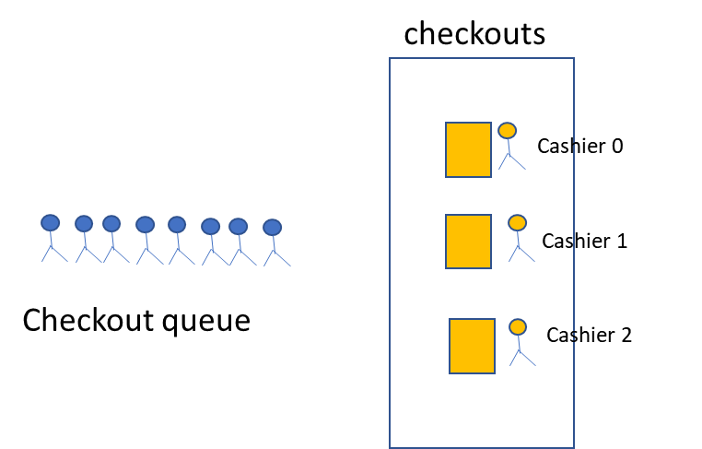

Cashier 0 in checkout

Cashier 1 in checkout

Cashier 2 in checkout

Customer 2 goes to checkout queue

Customer 3 goes to checkout queue

Cashier 0 serving Customer 2

Customer 4 goes to checkout queue

Customer 0 goes to checkout queue

Customer 2 goes to cashier 0

Customer 1 goes to checkout queue

Customer 3 goes to cashier 1

Cashier 1 serving Customer 3

Customer 5 goes to checkout queue

Customer 2 pays and go

Customer 6 goes to checkout queue

Customer 3 pays and go

Cashier 2 serving Customer 0

Customer 0 goes to cashier 2

Customer 8 goes to checkout queue

Customer 4 goes to cashier 0

Cashier 0 serving Customer 4

Customer 7 goes to checkout queue

Cashier 1 serving Customer 1

Customer 1 goes to cashier 1

Customer 4 pays and go

Customer 0 pays and go

Customer 1 pays and go

Customer 5 goes to cashier 0

Cashier 0 serving Customer 5

Customer 9 goes to checkout queue

Customer 6 goes to cashier 2

Customer 5 pays and go

Customer 8 goes to cashier 1

Cashier 1 serving Customer 8

Cashier 2 serving Customer 6

Customer 7 goes to cashier 0

Customer 8 pays and go

Cashier 0 serving Customer 7

Customer 6 pays and go

Customer 7 pays and go

Customer 9 goes to cashier 1

Cashier 1 serving Customer 9

Customer 9 pays and go

Goodbye